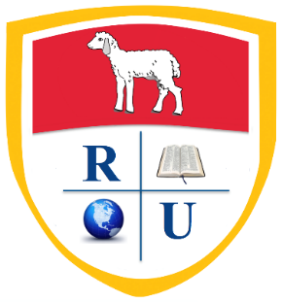
Revelation University Inc.
10658 SW 186th Street
Miami, Florida 33157
(305) 969-9448 Fax: (305) 969-9748
www.revelationuniversity.us

NEWS RELEASE
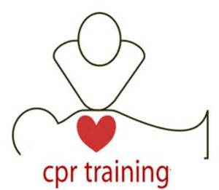
Revelation University Inc. is offering CPR – Basic Life Support for Health Care Providers!!

As certified and approved American Heart Association Instructor, we are offering the course so you may be in compliance with your health care profession. Although there are many providers for BLS, American Heart Association is now the most credible and acceptable for those working in health care, specifically, hospitals, hospice, and those performing clinical and public service work.

So don’t miss out – obtain your credible CPR -BLS Training now. Our fees:

- $70.00 - Renewals – must not have credentials expired for more than 3 months to qualify. A two-hour class. Credentials will be valid for two years.

- $80.00 – Initial four-hour course. Credentials will be valid for two years.
Group Rate no more than 12 People at a time and must have 12 people.

- $65.00 - Renewals – Renewals – must not have credentials expired for more than 3 months to qualify. A two-hour class. Credentials will be valid for two years.

- $78.00 – Initial four-hour course. Credentials will be valid for two years.

Thank you for choosing our organization.

